Recommendations:

Working or non-working day as per our data we see that it doesnt have any effect on population mean of the people renting  cycles , so its better to have cycles ready for both periods.

As we see the correlation we see that humidity have negative impact on no of cycles rented , but the it cant be proved as we proved for temp below , so its better to be prepared and it also make sense as when humidity is less people will be easily breath which will make them to do more physical activity like cycling.

Below recommendation is with 95 percent confidence.

There is a lot of potential that season 2 and season 3 will have better count than other seasons , especially if yulu decides on focusing one season which will create lot of demand in cycle is season 3.

As per the data given we believe the strong reasons are:

population mean of Temp is higher at season 3 than any other season in which we also get more number of cycles rented , Yulu can follow this pattern as a day is good sunny day chances of people renting cycle increases.

Above reason also proved by checking with respective weather , which weather had population mean of high temp had a high population mean count of cycles rented.

season and weather are dependent which implies can also find which season will contain more sunny days , which should be season3.

Insights:

Working Day has effect on number of electric cycles rented.

T- Test - two sided:

Null Hypothesis is both population mean of number of cycles/bikes rented are same for Working and non working.

Alternative Hypothesis is both population mean of number of cycles/bikes rented are not equal for Working and non working.

Significance = 5%

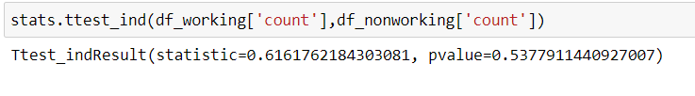

Pvalue is significantly greater than .05 , so we can conclude with it that both population mean are same. Which says that count of bikes doesnt depends on working or non working day , Yulu should be prepared to expect approximately equal numbers.

Temp have positive correlation with count of cycles rented

Humidity have negative correlation with count  of cycles rented

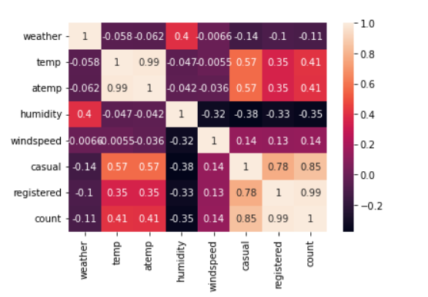

 With this data we are going to compare season or weather vs temp or humidity or count by checking each comparison population mean using different Hypothesis tests.

Anova:

Weather  --  Population mean of  No. of cycles rented is similar or different in different weathers

Null Hypothesis -- All mean populations of the weather are same

Alternative Hypothesis -- Not all are equal

Significance level = 5% percent

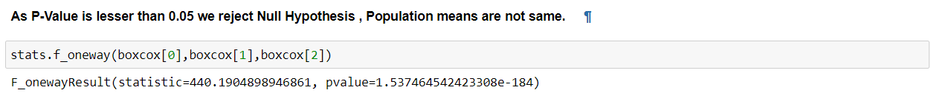

As we know population mean for all weathers are not equal and from above we discovered approximated weather 1 and weather 2 have high mean lets do Hypothesis testing on these 2 weathers

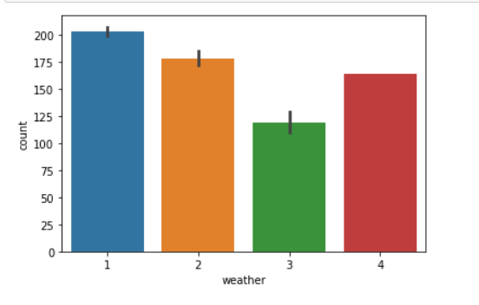

T-Test -- One Sided

Null Hypothesis -- weather1 and weather2 population mean are same for number of bikes.

Alternative Hypothesis -- weather1 population mean for number of bikes is greater than weather2 population mean for number of bikes.

Significance value = 5%

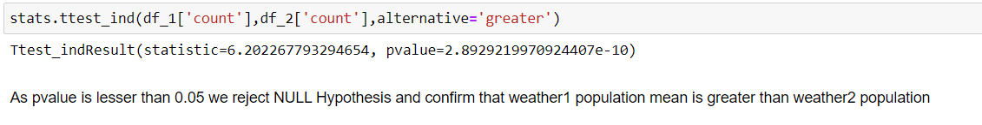

Season  --  Population mean of No. of cycles rented is similar or different in different seasons

Null Hypothesis -- All mean populations of the season are same

Alternative Hypothesis -- Not all are equal

Significance level = 5% percent

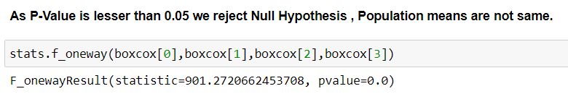

As we know population mean for all seasons are not equal and from above we discovered approximated season 2 and season 3 have high mean lets do Hypothesis testing on these 2 seasons

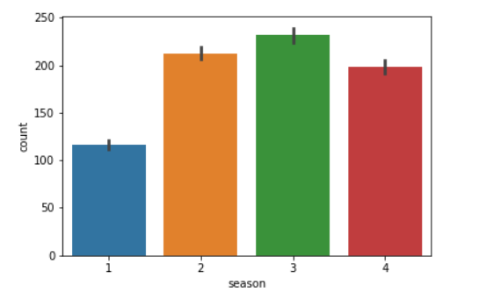

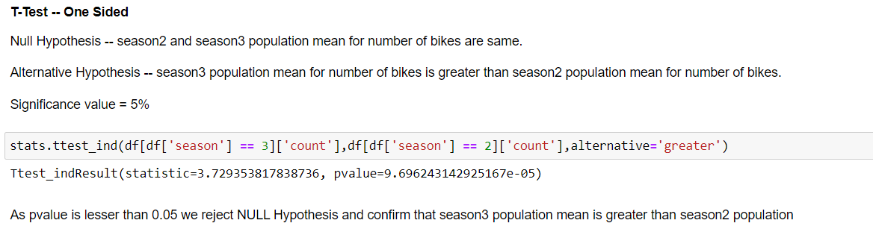

Temp Vs season:

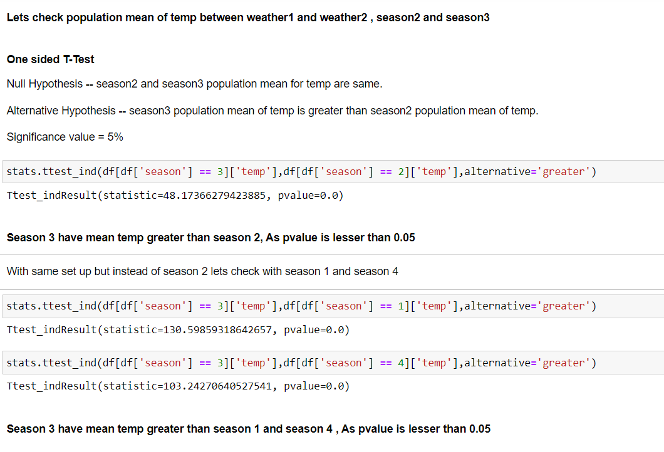

Temp vs weather

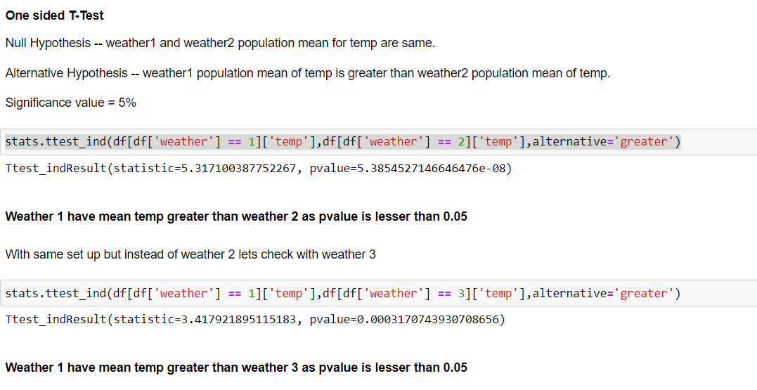

Humidity vs season:

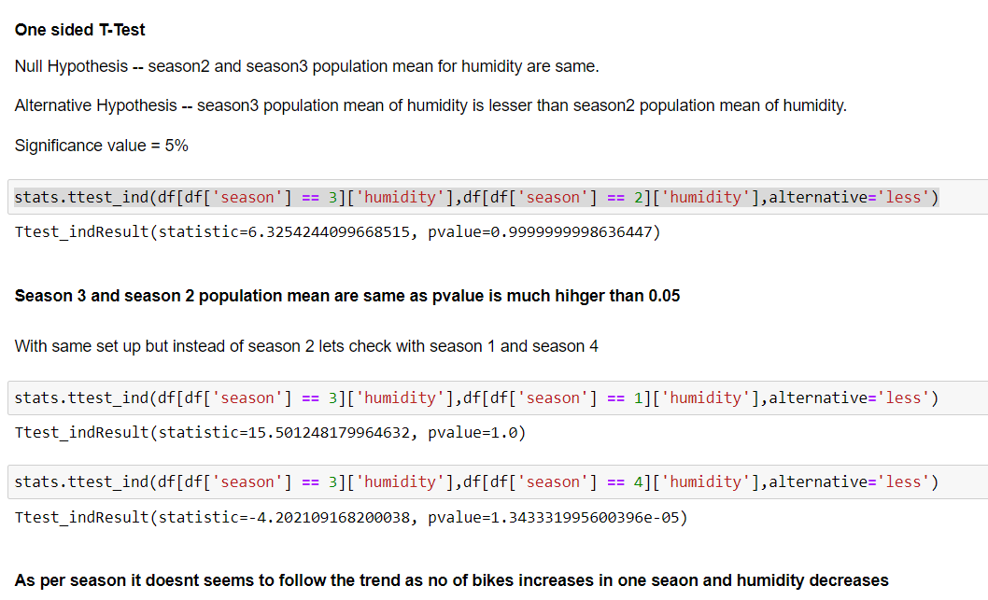

Humidity vs weather:

